**Stake Holder analysis for NiteRest Hotels project**

**Identify Stakeholders**

* Executive Director of Hotel group (Make decision to implement HotelWare)
* Customer
* Hotel Staff
* Head Office Staff
* SASG(Sleep Away Software Group)
* The supplier: Microland Corporation (main contractor and System Integrator)

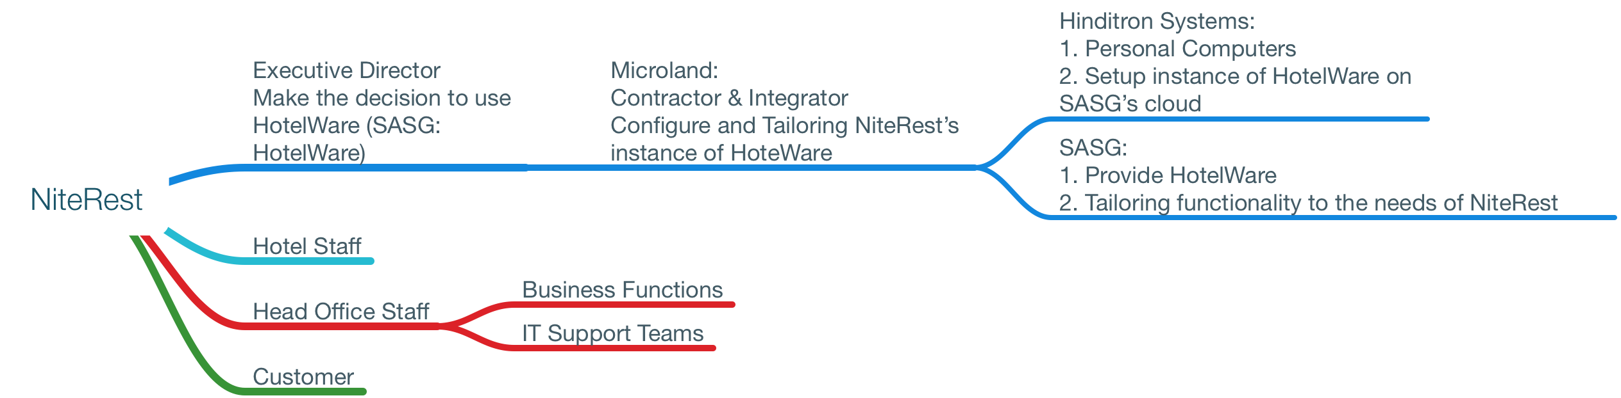

**Prioritise Stakeholders**

Executive Director

Project Management Team leader

CFO

**Stakeholder Mapping**

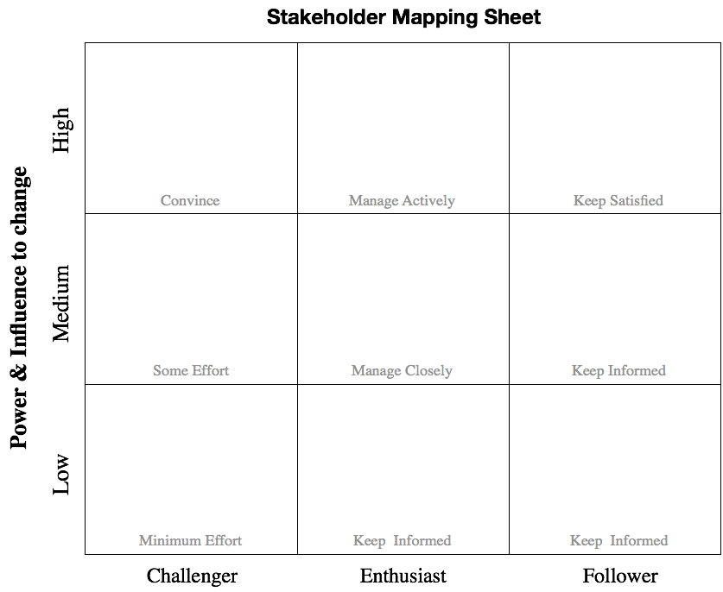

**Stakeholder Action Plan**